College Complaint and Issue Management System


A Project Report submitted to
The Maharaja Sayajirao University of Baroda
in the partial fulfilment for the award of the degree of

Post Graduate Diploma in Computer Applications
at
The Department of Applied Mathematics
by
Grena Panchal (Seat No. - 260209)
Manav Bhatt (Seat No. - 260201)

Under the Guidance of
INTERNALGUIDE
Dr. Nilima Shah
Department of Applied Mathematics,
Faculty of Technology & Engineering,
The Maharaja Sayajirao University of Baroda,
Vadodara.

April, 2026

CERTIFICATE
This is to certify that the project report entitled “College Complaint and Issue Management System” which is submitted by Grena Panchal and Manav Bhatt in partial fulfilment for the award of the degree of Post Graduate Diploma in Computer Application at The Department of Applied Mathematics, The Maharaja Sayajirao University of Baroda has been carried out under our supervision and guidance in the academic year 2025-2026.

INTERNAL GUIDE
Dr. Nilima Shah

Department of Applied Mathematics,
Faculty of Technology & Engineering,
The M. S. University of Baroda,
Vadodara.

Head,  Department of Applied Mathematics | Dean,  Faculty of Technology and Engineering
The Maharaja Sayajirao University of Baroda
Vadodara – 390001
CERTIFICATE

This is to certify that the project report entitled “College Complaint and Issue Management” submitted by Grena Panchal and Manav Bhatt in the partial fulfilment for the award of the degree of Post Graduate Diploma in Computer Application at The Department of Applied Mathematics, The Maharaja Sayajirao University of Baroda is hereby approved.

__________________________ __________________________

__________________________ __________________________

__________________________ __________________________

__________________________ __________________________

Date: _____________
Place: Vadodara
Department of Applied Mathematics
Faculty of Technology & Engineering
The Maharaja Sayajirao University of Baroda
Vadodara – 390001

ACKNOWLEDGMENT
We are highly thankful to our project guide Dr. Nilima Shah, Department of Applied Mathematics, Faculty of Technology & Engineering for providing her valuable insights and constructive suggestions during the development of the College Complaint and Issue Management System. Their guidance played a crucial role in shaping this project successfully.
We would also like to thank the Department of Applied Mathematics for providing us with the necessary resources and a supportive environment to carry out this work.
Finally, I would like to thank my friends for their cooperation to complete this project.

NAME OF STUDENTS
Grena Panchal
Manav Bhatt

ABSTRACT
The College Complaint & Issue Management System is a web-based application designed to simplify and streamline the process of handling complaints within a college environment. The system provides a centralized platform where students can register their complaints related to academic, administrative, or facility issues in an easy and structured manner.
The primary objective of this system is to replace the traditional manual complaint handling process, which is often time-consuming, inefficient, and lacks transparency. Through CCIMS, complaints are digitally recorded, categorized, and forwarded to the appropriate department or staff member for resolution. Users can also track the status of their complaints in real-time, ensuring better communication and accountability.
The system includes different user roles such as Admin, Staff, and Students, each having specific functionalities. Admin manages users and monitors the overall system, staff members handle and update complaints, while students can submit and track their issues.
By implementing this system, the college can improve efficiency, reduce paperwork, enhance transparency, and ensure timely resolution of complaints. Overall, CCIMS aims to create a more organized, responsive, and student-friendly environment within the institution.

CONTENTS

- INTRODUCTION - 8
  - INTRODUCTION TO PROJECT
  - PURPOSE OF THE PROJECT
  - PROBLEM IN EXISTING SYSTEM
  - SOLUTION OF THESE PROBLEMS

- SYSTEM ANALYSIS - 11
  - INTRODUCTION
  - ANALYSIS MODEL
  - STUDY OF THE SYSTEM
  - SOFTWARE REQUIREMENT
  - PROPOSED SYSTEM
  - INPUT AND OUTPUT

- FEASIBILITY REPORT - 15
  - TECHNICAL FEASIBILITY
  - OPERATIONAL FEASIBILITY
  - ECONOMIC FEASIBILITY

- SOFTWARE REQUIREMENT SPECIFICATION - 18
  - INTRODUCTION
  - FUNCTIONAL REQUIREMENTS
  - INPUT REQUIREMENTS
  - OUTPUT REQUIREMENTS
  - NON-FUNCTIONAL REQUIREMENTS

- SYSTEM DESIGN - 21
  - INTRODUCTION
  - SYSTEM WORKFLOW
  - USE CASE DIAGRAM
  - DATA FLOW DIAGRAM (DFD)
  - E-R DIAGRAM
  - DATA DICTIONARY

- OUTPUT SCREENS – 30
- CONCLUSION – 35
- REFERENCES - 38

Chapter - 1
Introduction

  - INTRODUCTION TO PROJECT

Nowadays, many colleges still handle complaints using manual methods like registers or verbal communication. This process is slow, inefficient, and sometimes complaints get lost or ignored. Students and staff often do not get proper updates about their complaints, which creates frustration and lack of transparency.

To solve this problem, we have developed a College Complaint & Issue Management System. This system is a web-based application that allows students and staff to submit their complaints online easily. Users can register, log in, and submit complaints related to various issues such as classrooms, library services, or administration.

The system also provides a feature to track the status of complaints. Users can check whether their complaint is pending, in progress, or resolved. On the other side, the admin (college authority) can view all complaints, manage them, and update their status.

This system reduces paperwork, saves time, and ensures that all complaints are stored safely in a database. It improves communication between students and college authorities and helps in faster resolution of issues.

Overall, the College Complaint & Issue Management System makes the complaint process simple, transparent, and efficient for both users and administrators.

  - PURPOSE OF THE PROJECT
The main purpose of the College Complaint & Issue Management System is to provide an easy and efficient way for students and staff to submit and manage complaints within the college.
In the existing system, complaints are usually handled manually, which takes more time and may lead to mismanagement or loss of data. This project aims to convert that manual process into a computerized system.
The system allows users to register and submit complaints online from anywhere. It also helps users to track the status of their complaints, which improves transparency and trust.
For the admin, the system provides a platform to view, manage, and resolve complaints in an organized manner. It helps in keeping proper records and reduces the workload.
Overall, the purpose of this project is to save time, reduce manual effort, improve communication, and make the complaint handling process faster, easier, and more reliable.

  - PROBLEM IN EXISTING SYSTEM

In many colleges, the complaint handling process is still manual and not well organized. This creates several problems for both students and administration.
- Complaints are usually written in registers or told verbally, which can easily get lost or ignored.
- There is no proper system to track the status of complaints.
- Students do not know whether their complaint is being processed or not.
- The process of resolving complaints takes more time.
- There is a lack of transparency between students and authorities.
- Managing records manually is difficult and may lead to errors.
- There is no proper communication system between users and admin.
Due to these problems, the existing system becomes inefficient and unreliable for handling complaints effectively.
  - SOLUTION OF THESE PROBLEMS

The development of the College Complaint & Issue Management System helps to overcome the problems of the existing manual system by providing an efficient and automated solution.
- The system allows users to submit complaints online easily from anywhere, reducing the need for manual registers.
- All complaints are stored securely in a database, so there is no risk of losing data.
- Users can track the status of their complaints at any time, which improves transparency.
- The system provides a clear communication channel between users and admin.
- Admin can manage, update, and resolve complaints in an organized way.
- The system reduces manual work and saves time for both users and administrators.
- Proper record management helps in maintaining history and future reference.
- Overall performance and efficiency of complaint handling is improved.
The new system makes the complaint process simple, reliable, and faster compared to the existing manual system.

Chapter - 2
System Analysis

  - INTRODUCTION

System analysis is an important phase in the development of any software system. It involves carefully studying the existing system to understand how it works, identifying the problems faced by users, and determining what improvements are needed. The main goal of system analysis is to gather accurate requirements so that a better, more efficient, and user-friendly system can be developed.
In the case of the current complaint handling system used in colleges, most of the processes are manual. Students usually submit complaints through written applications, emails, or by directly approaching staff members. This approach often creates several issues such as delays in processing complaints, misplacement of records, lack of proper tracking, and poor communication between students and authorities.
Since there is no centralized system, it becomes difficult to monitor the status of complaints or ensure accountability. Students are often unaware of whether their complaint has been addressed or not, which leads to dissatisfaction. Similarly, staff members face challenges in managing multiple complaints efficiently due to the absence of an organized system.
Through system analysis, we identify these limitations and understand the actual needs of users, including students, staff, and administrators. Based on this understanding, requirements for a new system are defined. The proposed system, which is the College Complaint & Issue Management System (CCIMS), aims to overcome these issues by introducing a computerized, structured, and automated solution.
The new system will allow easy submission of complaints, proper categorization, real-time tracking, and improved communication. Overall, system analysis helps in building a system that is more reliable, efficient, transparent, and user-friendly compared to the existing manual system.

  - ANALYSIS MODEL

The development of the College Complaint Management System follows a step-by-step process. First, the requirements of the system are collected and analyzed. After that, planning and system design are done. Then coding and testing are carried out before final implementation.

The main steps involved are:
- Requirement Analysis
- System Planning
- System Design
- Coding
- Testing
- Implementation
This model helps in developing the system in an organized and structured way.

  - STUDY OF THE SYSTEM

GUI (User Interface)
The system is divided into two main interfaces:
- Student Side Interface
- Registration and Login
- Submit Complaint
- View Complaint Status

- Staff Side Interface
- View Complaints
- Update Complaint Status
- Manage Users

NUMBER OF MODULES
The system is divided into the following modules:
- Registration Module
- Login Module
- Complaint Submission Module
- Complaint Tracking Module
- Staff Management

ENTITIES INVOLVED
- Student – Submits and tracks complaints
- Staff – Manages and resolves complaints
- HOD – Monitor reports
- Complaint – Stores complaint details

  - SOFTWARE REQUIREMENTS
Software Requirements
- Frontend: HTML, CSS, JavaScript, React.js
- Backend: Node.js, Express.js
- Database: MySQL
- Server: Apache

  - PROPOSED SYSTEM

The proposed system is a web-based application that automates the complaint handling process. It allows users to submit complaints online and track their status easily.

The system provides:

- Easy complaint submission
- Real-time tracking
- Secure data storage
- Efficient complaint management
It improves transparency, reduces manual work, and increases efficiency.

  - INPUT AND OUTPUT
Input
- User login details
- Complaint details (category, description)
- Admin updates
Output
- Complaint status (Pending, In Progress, Resolved)
- Admin responses
- Reports

Chapter - 3
Feasibility Report

The feasibility study is a key step in developing a system. It helps us understand whether the proposed system can be built and used successfully in a real environment. The main purpose of this step is to check if the College Complaint & Issue Management System is practical and worth implementing.
In this phase, we examine whether the system is technically possible with the available technology, whether it is cost-effective, and whether it will be accepted and easily used by students, staff, and administrators. This study ensures that the system will be useful, efficient, and beneficial before starting its actual development.

The feasibility of the system is divided into three types:
- Technical Feasibility
- Operational Feasibility
- Economic Feasibility

  - TECHNICAL FEASIBILITY

Technical feasibility checks whether the required technology and resources are available to develop and run the system.

- The system is developed using technologies like HTML, CSS, JavaScript, Node.js, and MySQL.
- These technologies are easily available and widely used.
- The system can run on standard computers and does not require high-end hardware.
- It is easy to maintain and can be upgraded in the future.
- The system ensures data accuracy, security, and reliability.
Therefore, the proposed system is technically feasible.

  - OPERATIONAL FEASIBILITY

Operational feasibility checks whether the system will work properly in the organization and be accepted by users.
- The system is user-friendly and easy to understand.
- Students and staff can use it without special training.
- It improves communication between users and administration.
- It reduces manual work and increases efficiency.
- There is no resistance from users as the system makes their work easier.
Hence, the system is operationally feasible.

  - ECONOMIC FEASIBILITY

Economic feasibility checks whether the system is cost-effective.
- The system uses open-source technologies, so development cost is low.
- No additional expensive hardware is required.
- It reduces paperwork and manual effort, saving time and money.
- Maintenance cost is minimal.
Therefore, the system is economically feasible.

Chapter - 4
Software Requirement
Specification

  - INTRODUCTION

Purpose

The purpose of this document is to describe the requirements of the College Complaint & Issue Management System. It provides a clear understanding of how the system will work and what features it will include. This document is useful for developers, testers, and users to understand the system and its functionality.

Scope

The system is designed to handle complaints within a college. It allows users to submit complaints and track their status, while the admin can manage and resolve them. The system helps in reducing manual work and improving efficiency.

Overview

The system is a web-based application that provides a simple interface for users and admin. It ensures proper complaint management, secure data handling, and faster communication.

  - FUNCTIONAL REQUIREMENTS

Functional requirements describe what the system should do.

User (Students) Functions

- User Can Register in the System.
- User can login using username and password
- User can submit complaints
- User can view complaint status

Users (Staff) Functions

- Staff can login securely
- Staff can view all complaints
- Staff can update complaint status
- Staff can generate reports

System Functions

- Store complaints in database
- Maintain complaint history
- Provide status updates
- Ensure secure login system

  - INPUT REQUIREMENTS

- User details (PRN ID(Unique), password)
- Complaint details (category, description)
- Staff inputs (status updates, Complaint assignment update)

  - OUTPUT REQUIREMENTS

- Complaint status (Pending / In Progress / Resolved)
- Complaint details display
- Reports for admin

  - NON-FUNCTIONAL REQUIREMENTS

Performance Requirements
The system should provide fast and efficient performance to ensure a smooth user experience. It must respond quickly to user actions such as login, complaint submission, and status checking. The system should be capable of handling multiple users at the same time without slowing down. It should also process and retrieve data from the database efficiently, even when the number of complaints increases. Overall, the system should maintain accuracy and speed while performing all operations.

Security Requirements
The system should ensure proper security to protect user data and prevent unauthorized access. It must provide a secure login system with authentication for both users and admin. Only authorized users should be allowed to access specific features based on their roles. The system should store data securely in the database and prevent misuse or loss of information. It should also ensure that user passwords and sensitive information are protected, maintaining privacy and data integrity at all times.

Chapter - 5
System Design

  - INTRODUCTION

System design is the process of planning how the system will work after understanding all requirements. It defines the structure, components, and working of the system. In the College Complaint & Issue Management System, the design focuses on creating a simple, user-friendly, and efficient system that allows users to submit complaints and track them, while the admin can manage and resolve them easily.

  - SYSTEM WORKFLOW

The working of the system can be explained in the following steps:

User Login/Registration
+
Submit Complaint
+
Complaint Stored in Database
+
Staff Reviews Complaint
+
Staff Updates Status
+
User Views Updated Status

This workflow shows how data moves from user to admin and back to the user.

5.3 Use Case Diagram: -

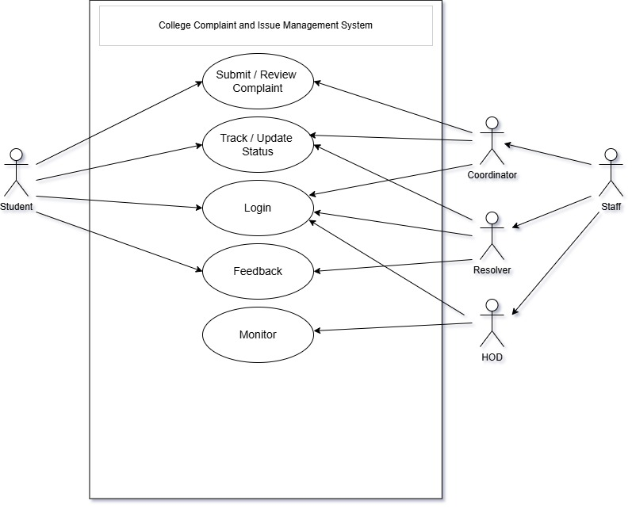

  - DATA FLOW DIAGRAM (DFD)

DFD shows how data flows in the system.

Level 0 DFD

- User submits complaint
- System processes complaint
- Admin manages complaint

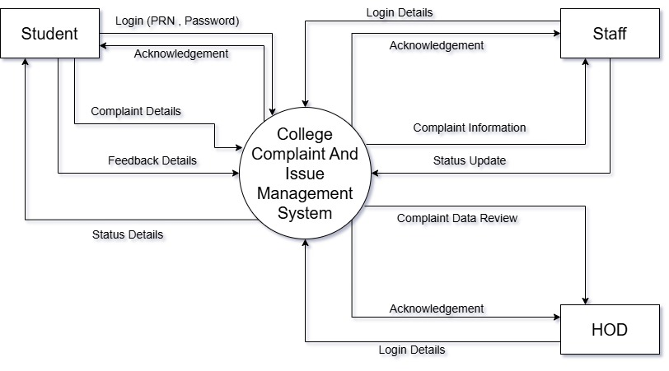

Level 1 DFD
- Login Process
- Complaint Submission
- Status Update

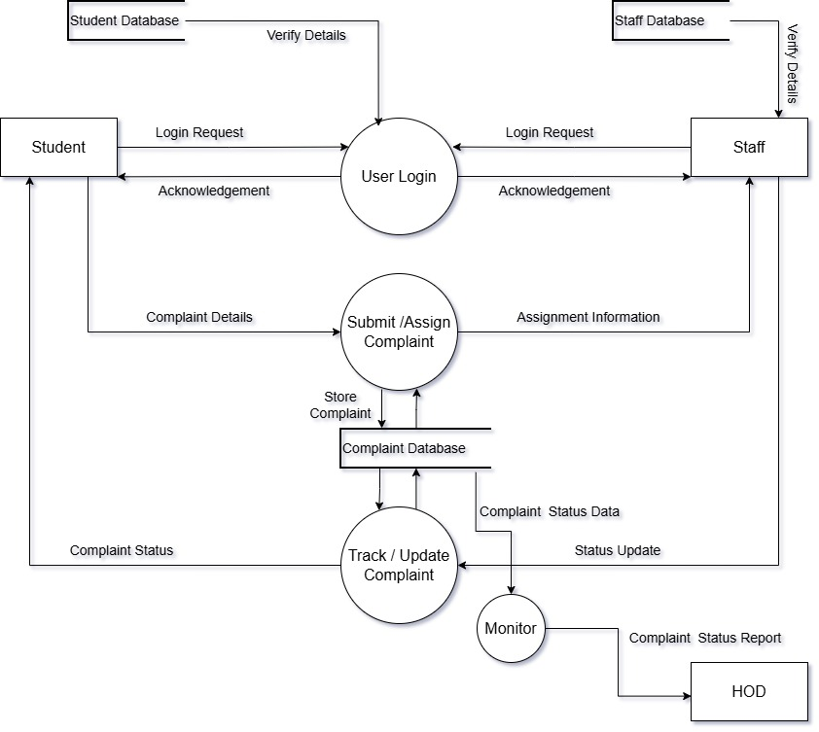

  - E-R DIAGRAM
The Entity-Relationship (ER) diagram represents the relationship between different entities in the system.

Main entities are:
- User
- Complaint
- Admin

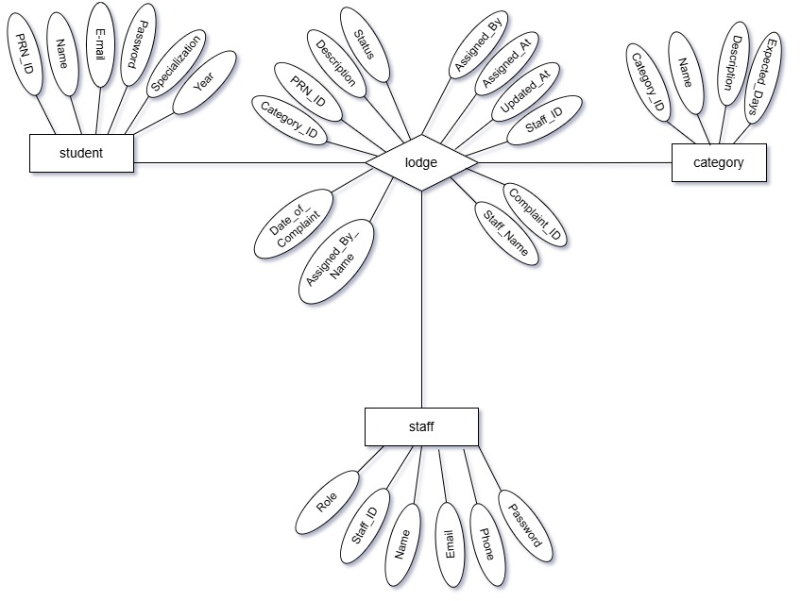

  - DATA DICTIONARY

Student table: -
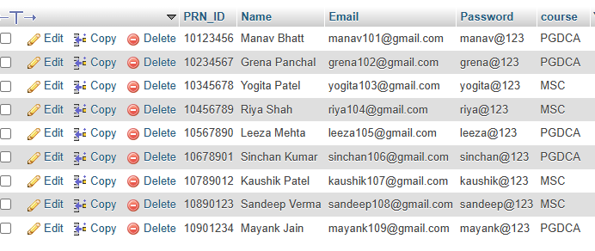

Staff table
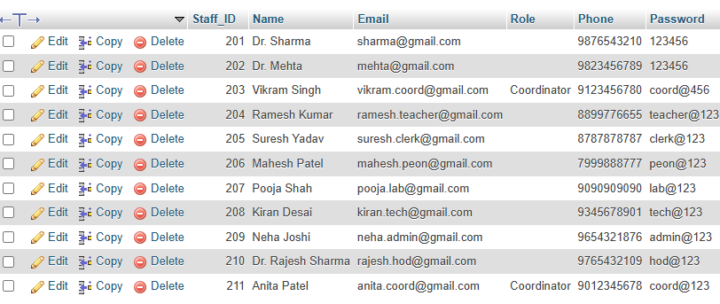

Complaint table
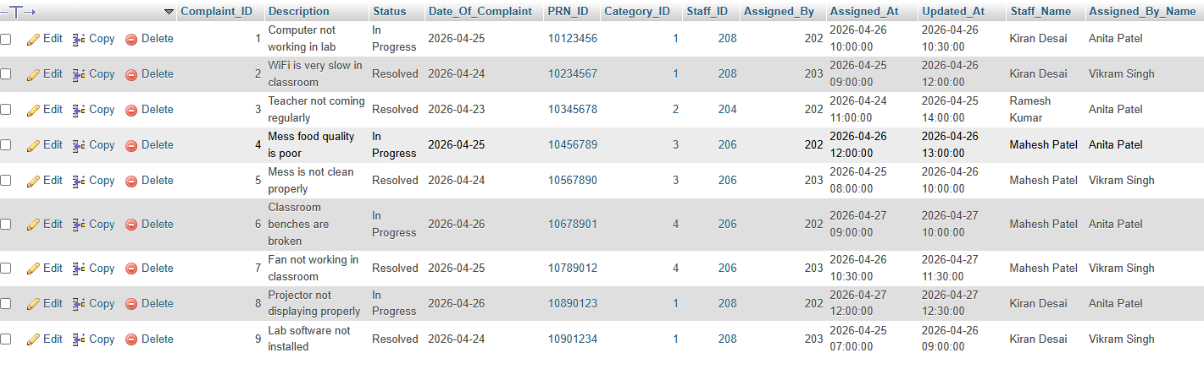

Category table
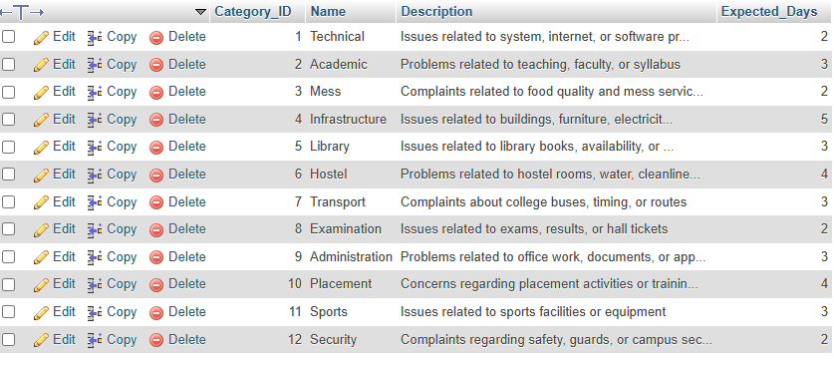

Chapter - 6
Output Screens

HOME PAGE
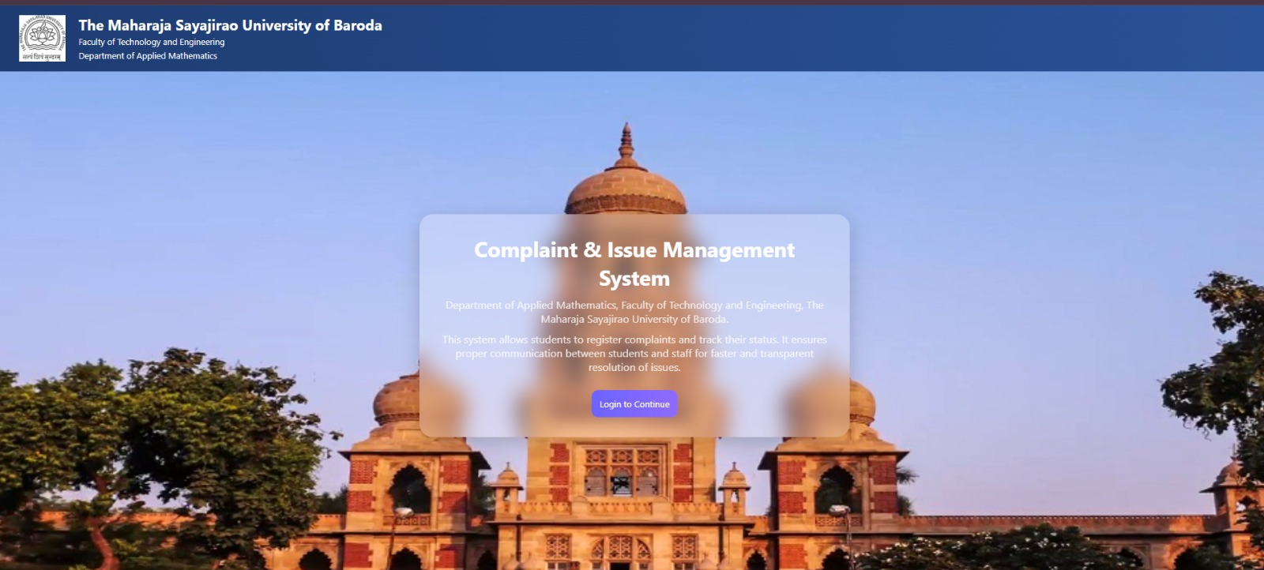

STUDENT LOGIN PAGE
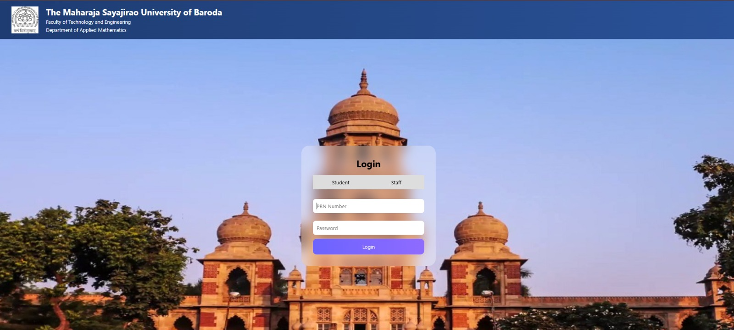

STAFF LOGIN PAGE


STUDENT DASHBOARD


STUDENT COMPLAINT STATUS PAGE
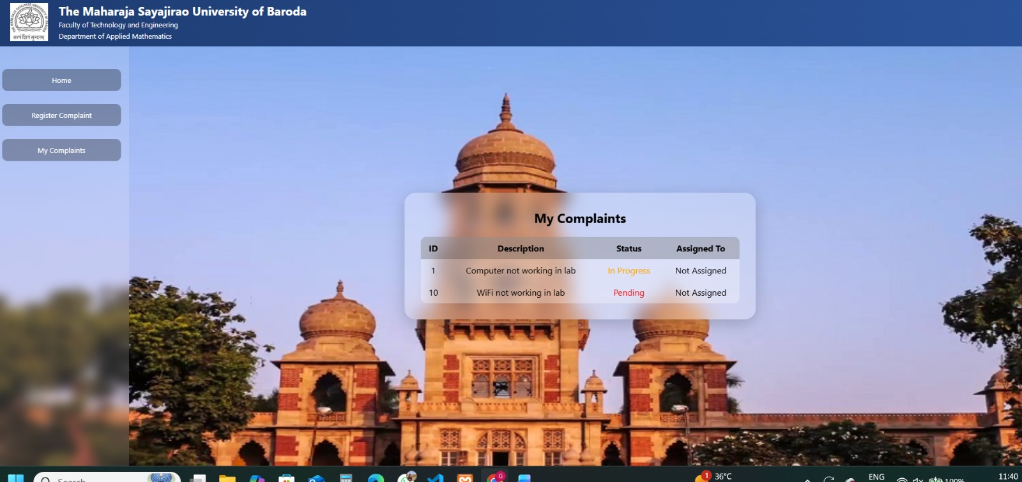

STUDENT COMPLAINT PAGE
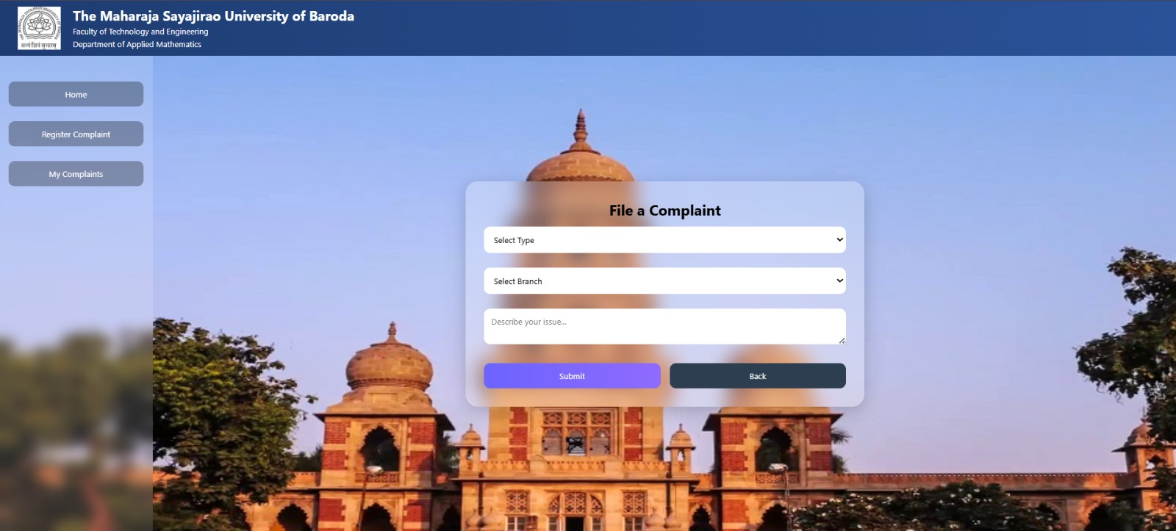

STAFF DASHBOARD
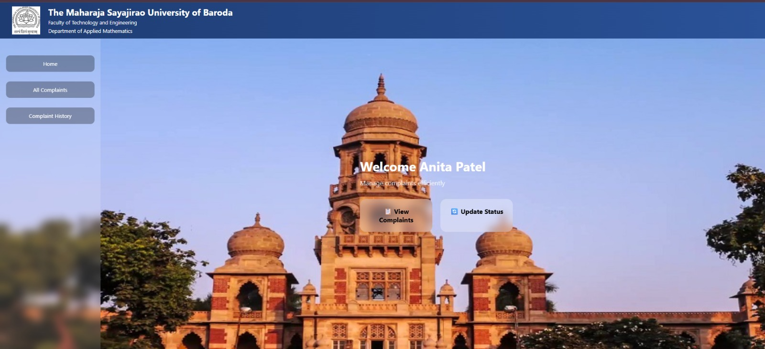

COMPLAINT DETAILS
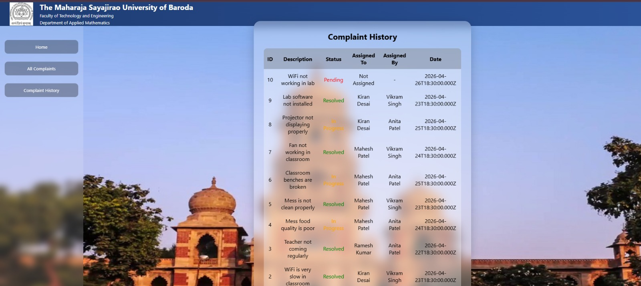

Chapter - 7
CONCLUSION

The College Complaint Management System has been developed to simplify and improve the complaint handling process within a college. The system provides an easy and efficient way for students and staff to submit their complaints online without any difficulty.
This project replaces the traditional manual system with a computerized system, which helps in reducing paperwork, saving time, and avoiding data loss. It ensures that all complaints are properly recorded and can be tracked at any time by the users.
The system also improves communication between students and the college administration. The admin can manage complaints in an organized way and update their status, which increases transparency and trust among users.
Through this project, we gained practical knowledge about web development, database management, and system design. It helped us understand how real-world systems are developed and implemented.
Overall, the system is user-friendly, efficient, and reliable, and it successfully achieves the objective of improving complaint management in a college environment.

Chapter - 8
References

Websites: -

- https://www.w3schools.com/

- https://nodejs.org/en/docs

- https://expressjs.com/en/guide

- https://react.dev/learn

